Data Grid 2 Row selection

Objective: To retain the selected row of the data grid even after the user has flipped multiple pages.

Solution:

1. In the required entity you may add a Boolean attribute with name **isSelected**.
2. On the on-click action of the data grid add mark isSelected attribute for the selected row as true (refer to the to the microflow ACT_Highlighted in code base url) and mark false for the others.
3. On the datagrid2 dynamic class section add the following class or you may create your own custom class.

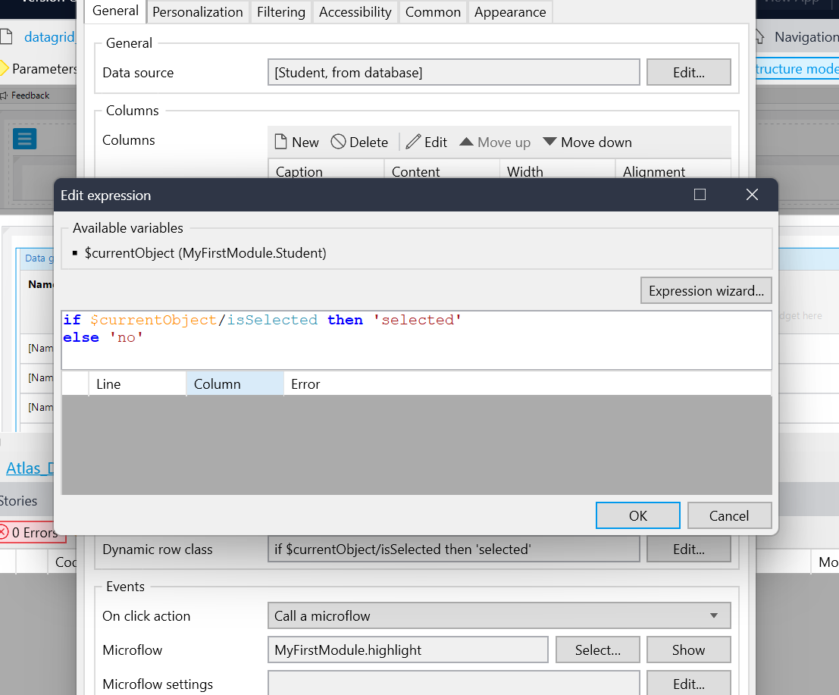

Now the selected row will remain highlighted even if we switch to the next pages and come back to the original page